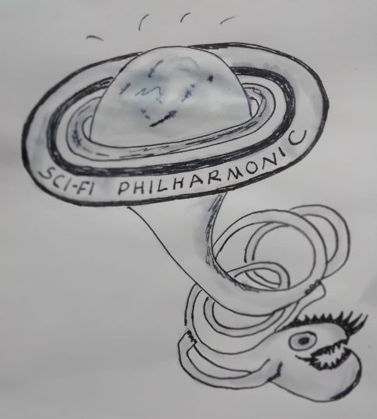
SCI-FI PHILHARMONIC

New Music sessions in Knighton

Taster session:
Saturday May 6th, St Edward’s Church Hall,
Knighton LD7 1AG

Followed by workshops on May 13th, May 27th all day.
June 24th all day.
Dates in September to be confirmed.

Age 16 and above, acoustic instruments only, any level of experience, no sight-reading required.

In the workshops we will explore creating music and sound for theatre, opera and film, with the long term aim of forming a new ensemble with a focus on sci-fi.

Sliding scale £2-5 per session, under-18s free.

For more details and to book a place, contact

Sonia 07891 450168 or Camilla 07399 412030

Facebook

Email camilla@littleweed-music.org

